**DAILY ONLINE ACTIVITIES SUMMARY**

|  |  |  |  |  |  |  |  |
| --- | --- | --- | --- | --- | --- | --- | --- |
| **Date:** | **12/06/2020** | | | | **Name:** | **ROHAN VASHISTA BM** | |
| **Sem & Sec** | **6th Sem & B** | | | | **USN:** | **4AL17CS078** | |
| **Online Test Summary** | | | | | | | |
| **Subject** | |  | | | | | |
| **Max. Marks** | |  | | **Score** | |  | |
| **Certification Course Summary** | | | | | | | |
| **Course** | **Java programming** | | | | | | |
| **Certificate Provider** | | | **Great learning** | **Duration** | | | **5 hrs** |
| **Coding Challenges** | | | | | | | |
|  | | | | | | | |
| **Status: completed** | | | | | | | |
| **Uploaded the report in Github** | | | | **yes** | | | |
| **If yes Repository name** | | | | <https://github.com/Rohanvasista/Coding-activities> | | | |
| **Uploaded the report in slack** | | | | **yes** | | | |

**ONLINE TEST DETAILS**

**CERTIFICATION DETAILS**

**Modules completed**

* Variables and data types
* Operators and flow control statements
* Arrays and functions

**CERTIFICATION DETAILS**

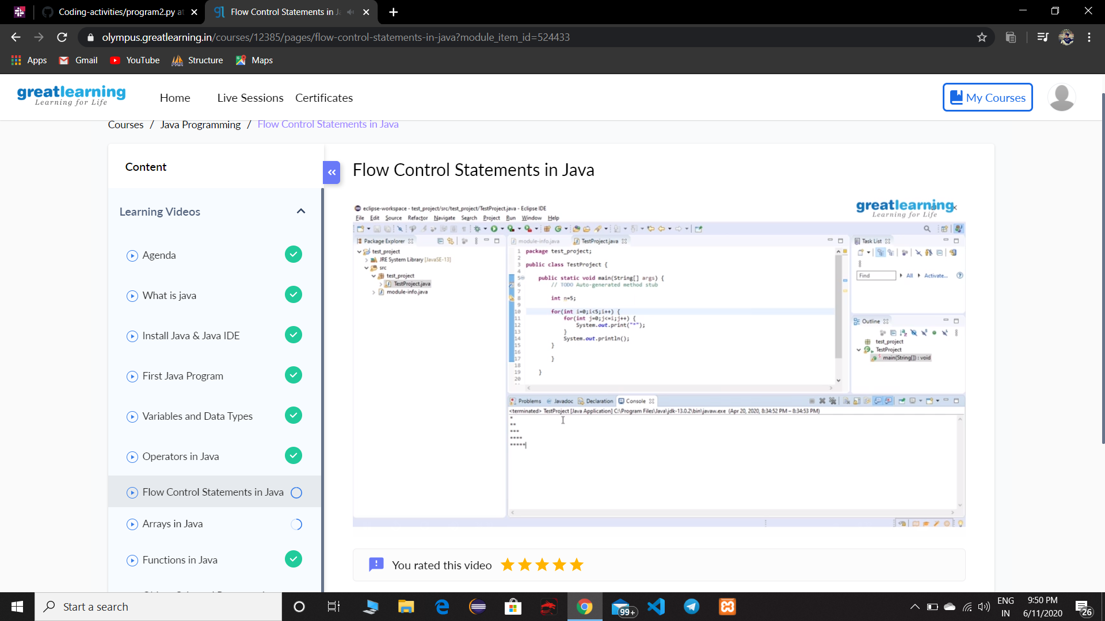

**Coding Challenge Details**

**1**.Python program to find product of two arrays and count number of zeros in that array if any

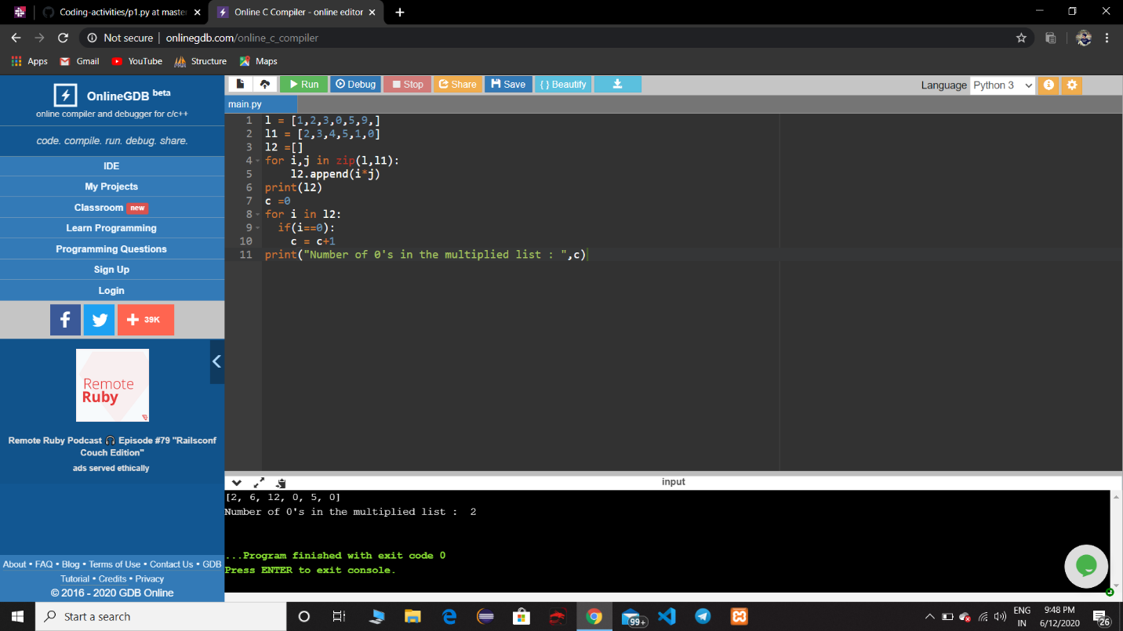

**2.** Python program to Count the Number of Vowels Present in a String using Sets



  
  
  
  
  